# **HOME PAGE**

**Menu**

1. Home
2. Services
3. About us
4. Team
5. Contact us
6. Book A Consultation

https://kodesolution.com/html/2023/desix-html/index.html

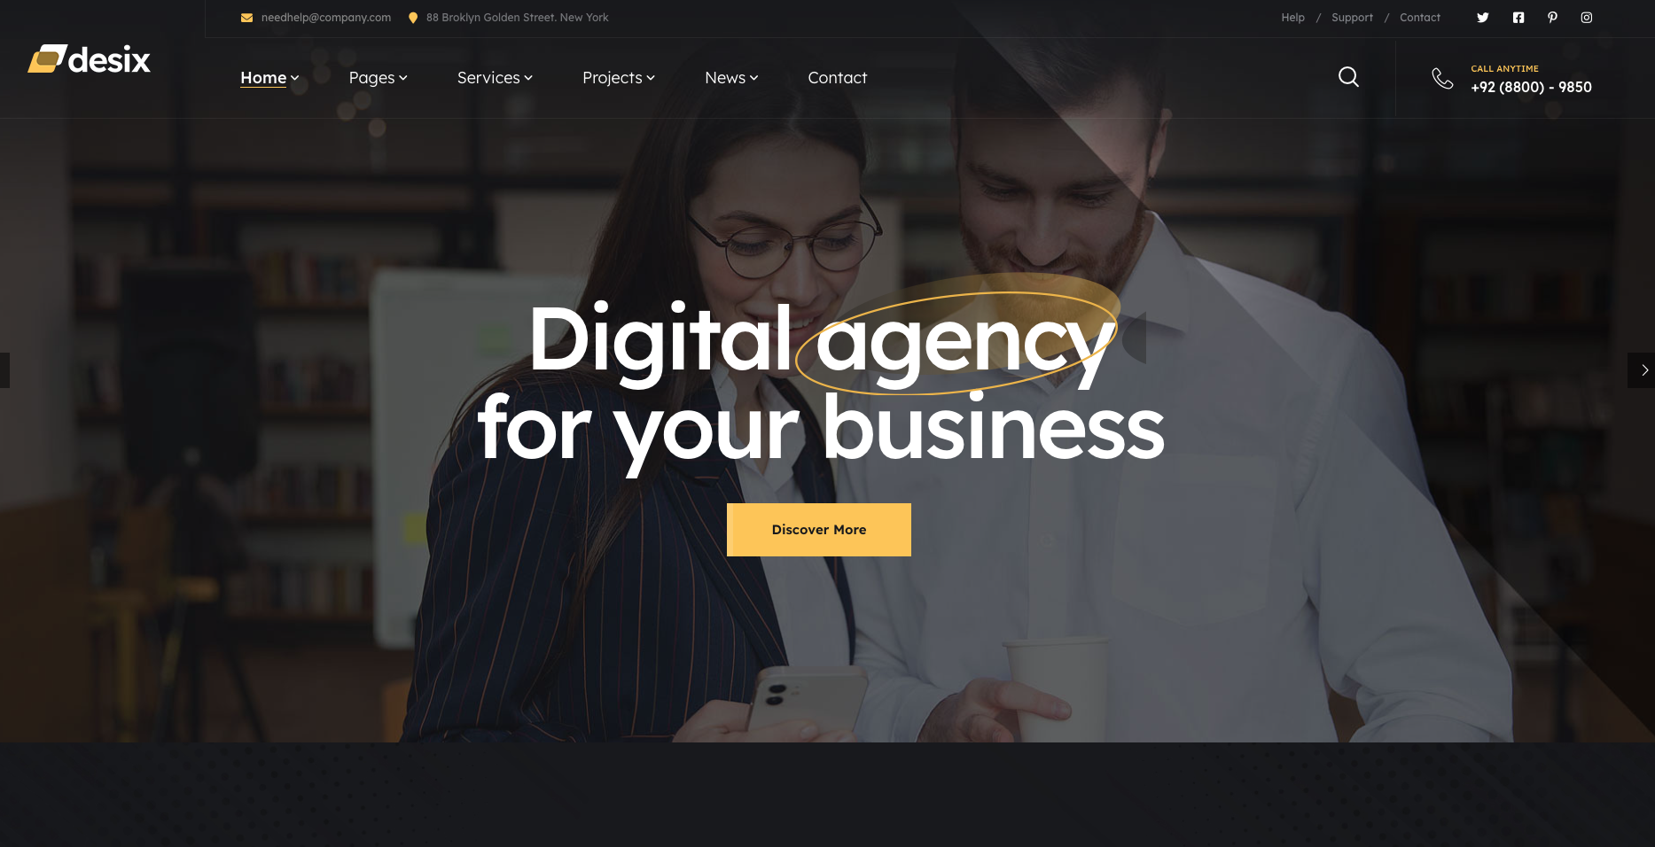

Use email: [info@digitalmonks.ca](mailto:info@digitalmonks.ca) & Instagram Icon on the top

Remove search

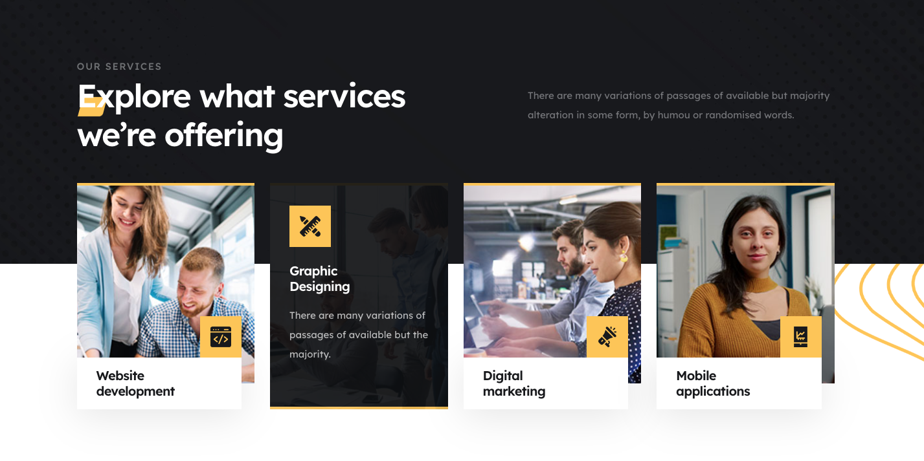

Website Development

Digital Marketing

Content Services

Marketing Strategy Consultations





No changes in the marque

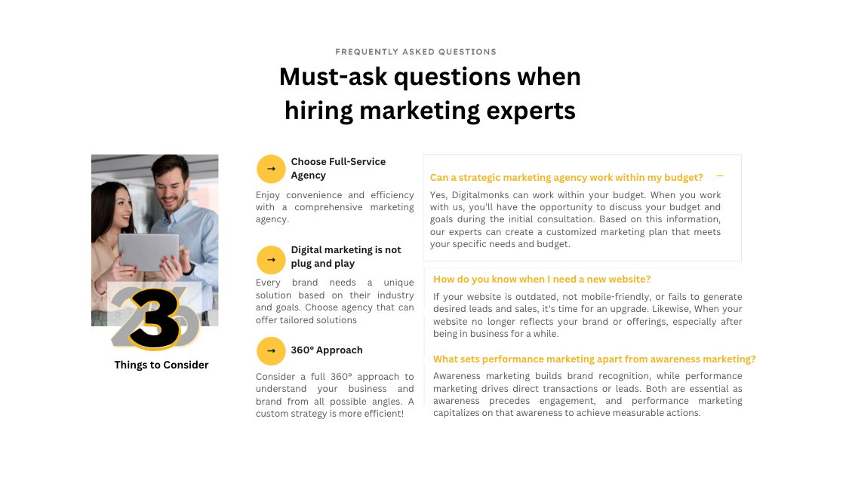

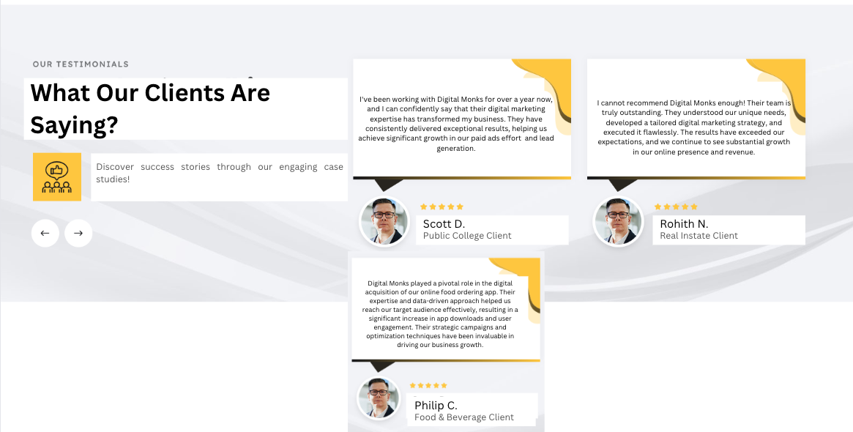



1. Why choose us?
   1. Highly professionals
   2. Quick turnaround
   3. Affordable services

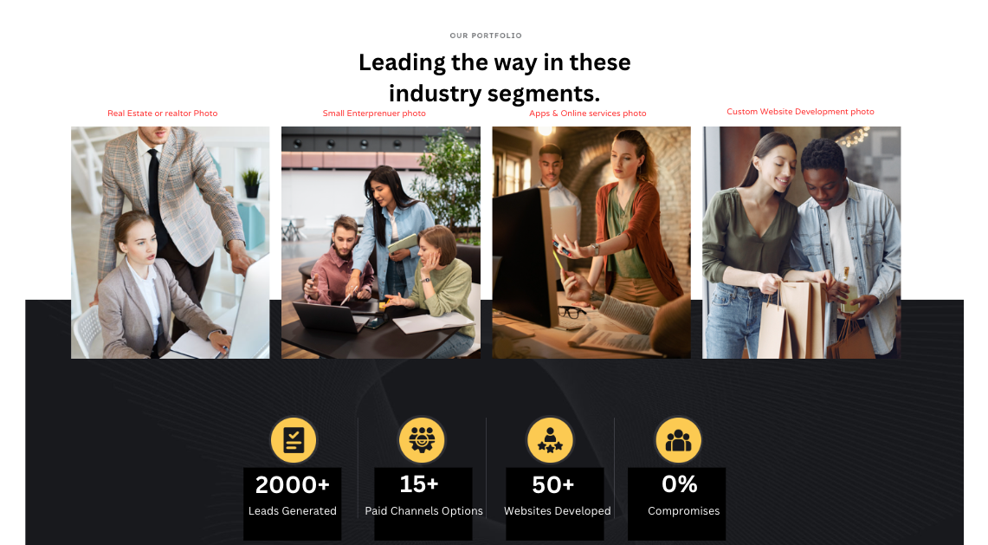

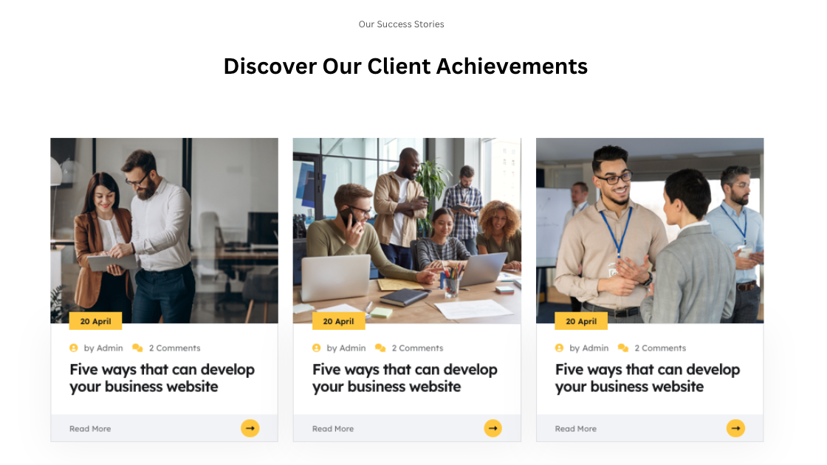

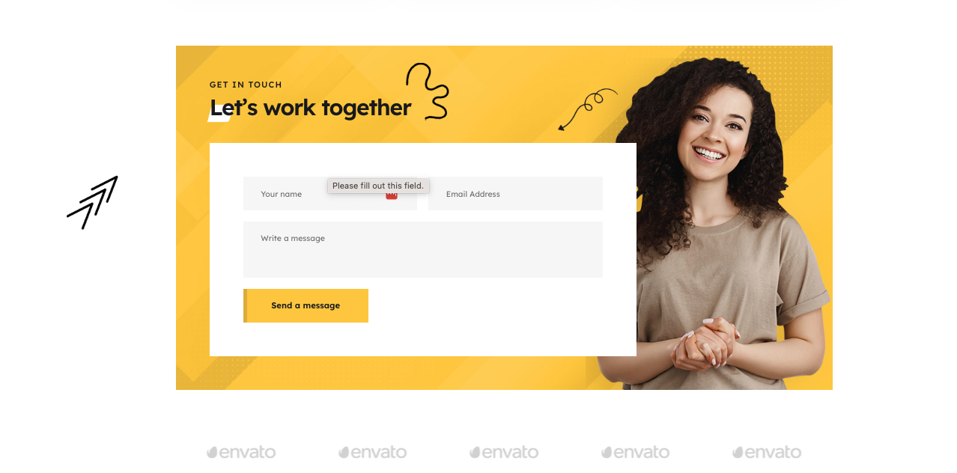

**Edits 04-07-2023**

1. Remove address and help/support/contact links only email and Instagram link to be retained



1. Replace the call button with “book a consultation” with a button like the previous website draft



1. Add

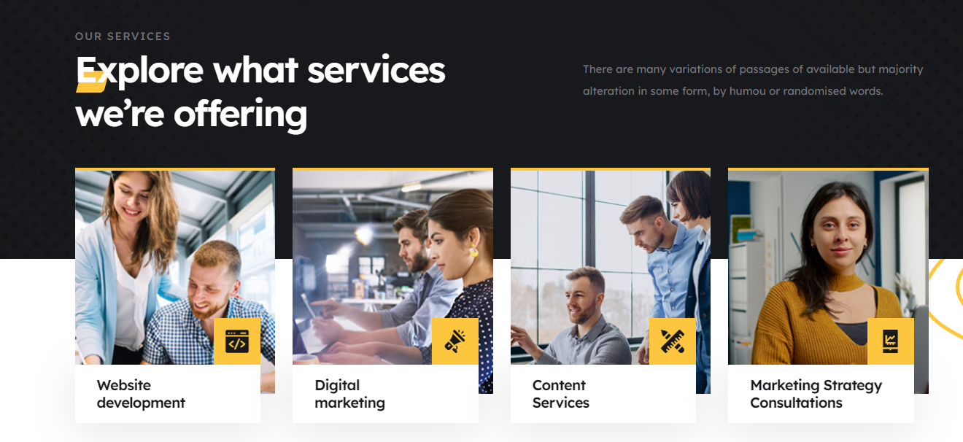

1. Replace 38+ work experience with 1:1 consultations as shown below
   1. Book an ask us anything button should redirect to book a Consultation page (calandly)



1. The caption mentioned above is image instructions for which type of image assets are to be selected for that particular section.
   1. Also, add the industry heading over the image as well as the given content box in the template as shown below
   2. Select images similar to this template images so that the look and feel remain the same.



1. Use the default user image for testimonials



1. Replace “from the blog” to “Case Studies”
   1. Replace checkout latest news updates & articles with “Explore Our Success Stories & Real-World Case Studies”

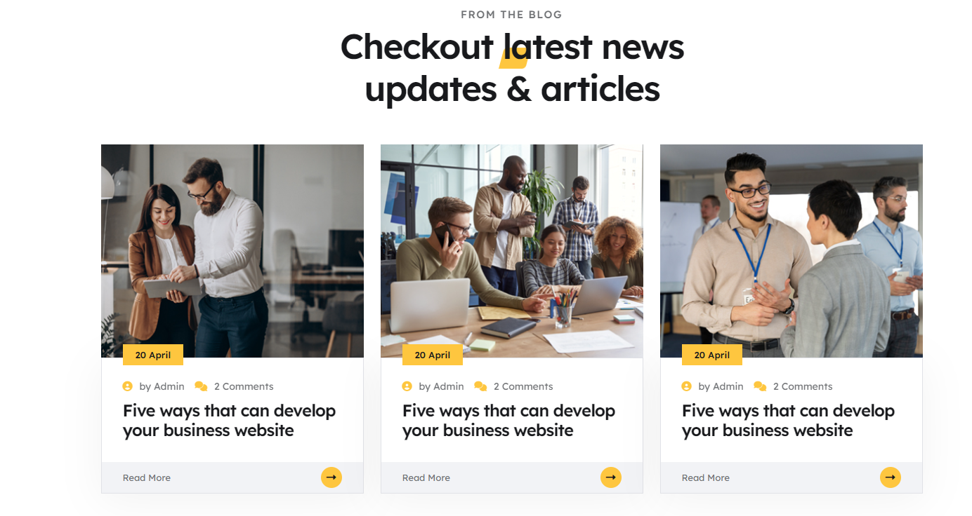

1. Use this section for platform logos such as meta, dv360, cm360 etc



1. Use the below-mentioned page as the about us page
   1. <https://digitalmonks.netlify.app/page-service-details.htm>
   2. Remove below sections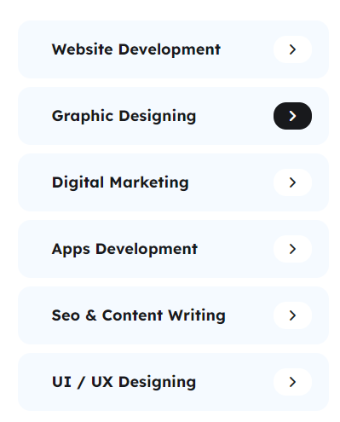
   3. Add the about us copy previously used in this section
   4. Retain this section and update the phone number
2. In the services page use this <https://digitalmonks.netlify.app/page-services.html> for mentioning services and this https://digitalmonks.netlify.app/page-pricing.html pricing section for the pricing section all in one page

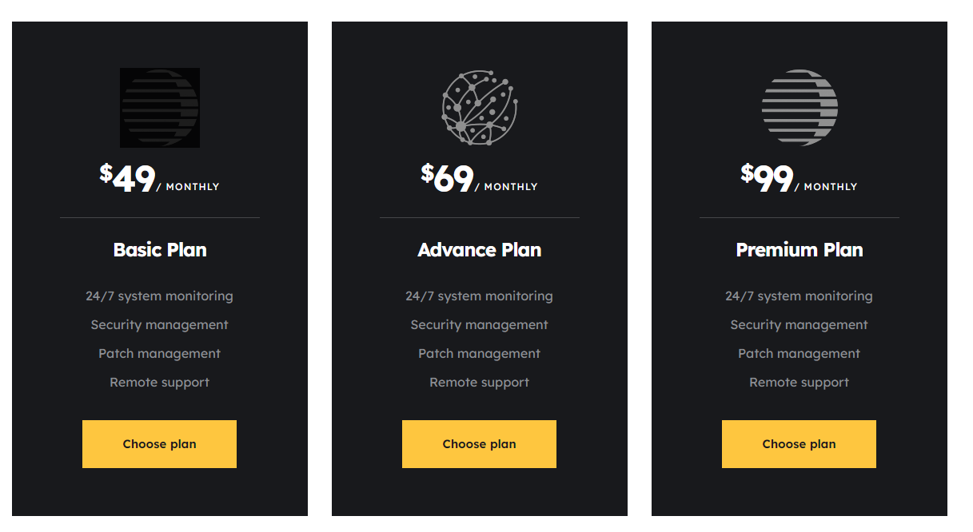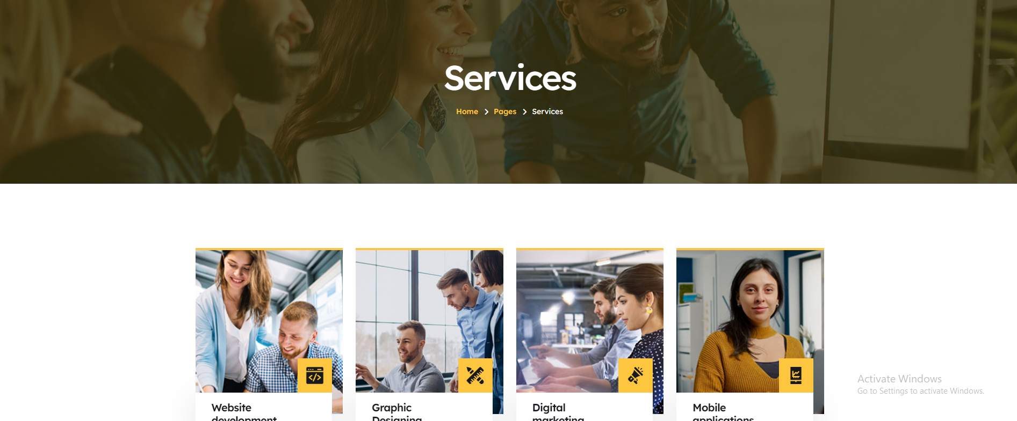

1. Use hubspot code for the contact form also update other details with previous draft copy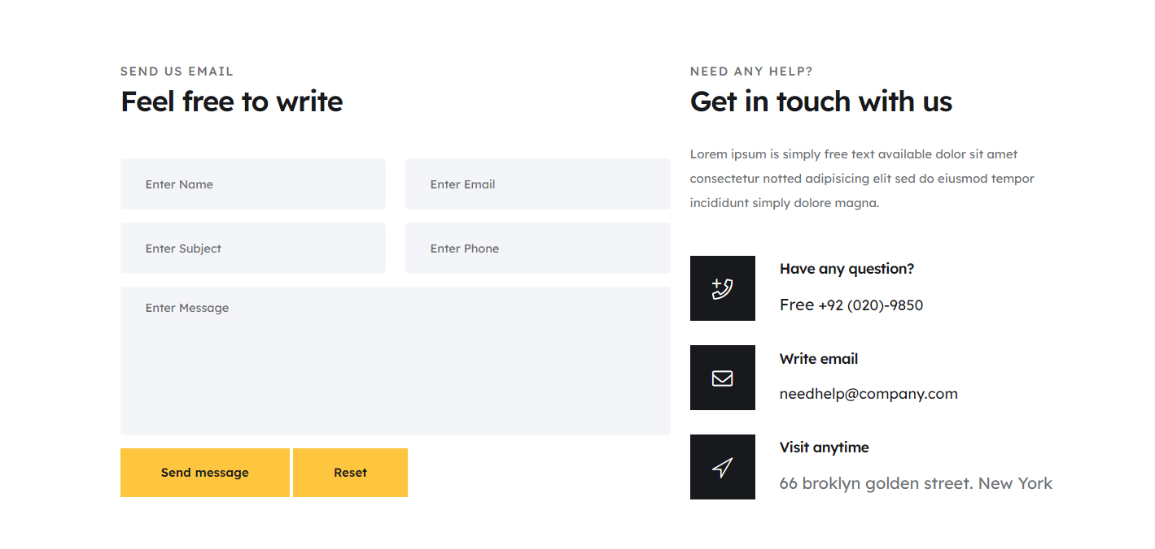
2. Remove this map section from contact us

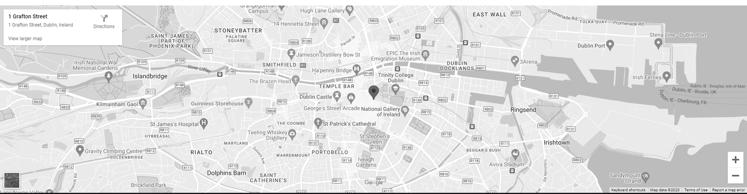

1. Use a bank page for book a consultation page with calendly code
2. Order the nav menu bar consistently across all pages currently it is using different navs menus is some pages